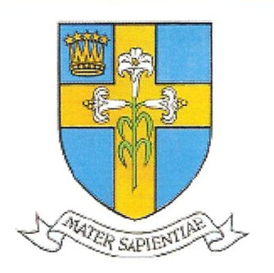
Call For Papers

The Mariological Society of America [MSA]

invites proposals for its

May 12–15 2020 Conference

to be held at the

Archbishop Brunett Retreat Center in Federal Way, WA

The Person of Mary: Her Cultural and ANTHROPOLOGICAL DIMENSIONS

In his 1974 apostolic exhortation, Marialis Cultus (nos. 34–41), St. Paul VI called attention to the anthropological dimensions of the person of Mary. Likewise the Congregation for Catholic Education, in its 1988 Letter, The Virgin Mary in Intellectual and Spiritual Formation (no. 15), noted that: “Post-conciliar Mariology has given renewed attention to anthropology. The Popes have repeatedly presented Mary of Nazareth as the supreme expression of human freedom in the cooperation of man with God, who ‘in the sublime event of the Incarnation of his Son, entrusted himself to the ministry, the free and active ministry, of a woman.’(Redemptoris Mater, 46).” This conference will seek to understand the person of Mary in terms of her concrete historical existence as well as her deeper anthropological significance for the human call to communion with God.
Among the topics that might be treated are the following:
The person of Mary as the model for human existence and meaning

Mary as the model of authentic womanhood

Evaluating Marian devotions in light of sound Christian anthropology

Mary’s person understood within her own Jewish religious and cultural setting

The person of Mary in light of contemporary anthropological theories

The person of Mary in light of human suffering and redemption

True and false understandings of the person of Mary in light of Scripture and tradition

The person of Mary as understood in mystical literature

The person of Mary as experienced in private vs. public revelation

Mary and the mystery of divine grace and human freedom

The person of Mary in light of divine providence and predestination

The anthropological significance of Mary’s Immaculate Conception

The anthropological significance of Mary’s divine and spiritual motherhood

Mary’s perpetual virginity in our age of the cult of the flesh

Mary’s perpetual virginity and the theology of the body

The Assumption of Mary in relation to Catholic eschatology

The person of Mary and divinization

The person of Mary as the exemplar of the divine image and likeness

Mary and the theological virtues

Mary and the gifts of the Holy Spirit

Mary and the charismatic gifts

Please send abstracts by October 31, 2019 to Fr. Frederick Miller (frederick.miller@shu.edu) and Dr. Robert Fastiggi (fastiggi.robert@shms.edu). The abstract should be about 350-500 words. It should include sources and an explanation of how the proposal relates to the theme of the conference.

